**• Matching identifiers**

Letter = [a-z]|[A-Z]

Digit = [0-9]

Identifier = letter (letter|_|digit)* , identifier | letter (letter|_|digit)*

**• Matching reserved words**

Yesif-Otherwise-------- > Condition

RepeatWhen/Reiterate-------- > Loop

**regular expressions**

Yesif-Otherwise -------- > Condition

RepeatWhen/Reiterate -------- > Loop

(+,-,*,/)-------- >Arithmetic Operation

(&&, ||, ~)-------- >Logic operators

(==, , !=, <=, >=) -------- >relational operators

(=)-------- >Assignment operator

(->)-------- >Access Operator

(,),[,]{,} -------- >Braces

“,’ -------- >Quotation Mark

/@-------- >Comment

@/-------- >Comment

/^ -------- >Comment

$-------- >Token Delimiter

. -------- >Line Delimiter

Omw -------- > Integer

SIMww -------- > SInteger

Chji -------- > Character

Seriestl -------- > String

IMwf -------- > Float

SIMwf -------- > SFloat

NOReturn-------- >Void

GetBack-------- > Return

OutLoop-------- >Break

Loli -------- > Struct

Include -------- > Inclusion

Start -------- > Start

Last -------- > End

All ----🡪**∑**{+,-,*,/, &&, ||, ~,==, , !=, <=, >=,=,->, ( , ) , [ , ] { , } , -> , “,’ , /@ ,@/ ,/^ , $, Include ,Start ,Last ,Omw , SIMww , Chji , Seriestl , IMwf , SIMwf , Yesif-Otherwise, RepeatWhen, Reiterate}

Identifier = letter (letter|_|digit)* , identifier | letter (letter|_|digit)*

Type ----🡪 Omw , SIMww , Chji , Seriestl , IMwf , SIMwf

Integers: [+]?[0-9]+

Floats: [+]?(([0-9]+ (.[0-9]⇤)?|.[0-9]+)([eE][+]?[0-9]+)?)

String constants: “([a-zA-Z0-9]|\[a-zA-Z])⇤”

Expr = ()

Statement = identifier

L(a) = identifier

**regular expression of Start**

R = Start

**regular expression of define var**

R = (ε |Type) (identifier | ,)+ (ε | = (Constant| identifier)).

**regular expression of Condition**

R = Yesif (identifier relational operators (identifier | Constant) )

{

(Statement (. | Last))*

}

Otherwise

{

(Statement (. | Last))*

}

**regular expression of Function**

R = (Type | void) identifier (ε | (Type identifier)*)

{

(Statement (. | Last))*

(ε | GetBack (. | Last))

}

**regular expression of Loop**

Reiterate

{

(Statement (. | Last))*

(ε | OutLoop (. | Last))

} RepeatWhen (identifier relational operators (identifier | Constant))

**regular expression of Include**

Include identifier (. | Last)

**regular expression of Struct**

Loli identifier

{

(Statement (. | Last))*

}

**Non-deterministic Finite Automata (NFA)**

**(NFA) of define var**

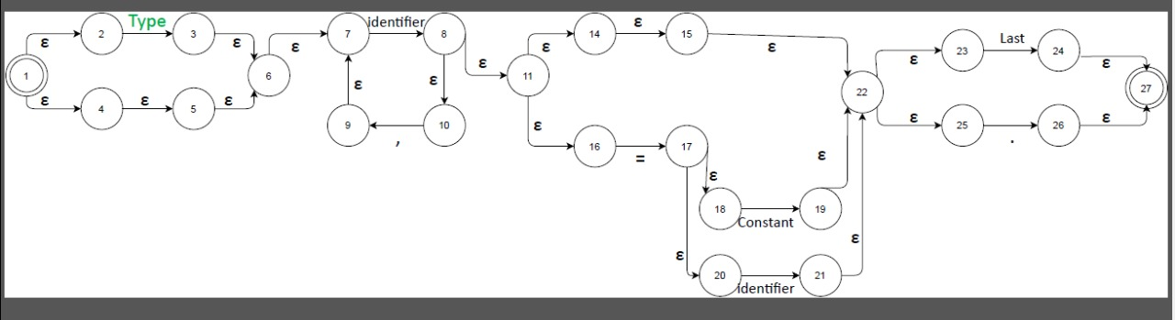

**(NFA) of Condition**

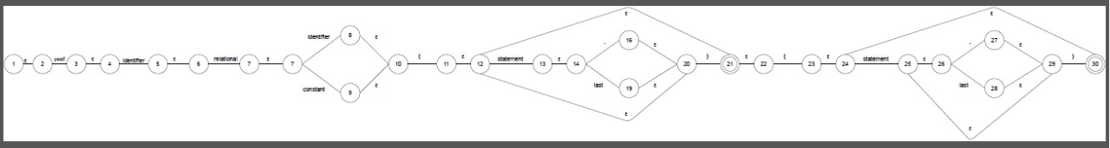

**(NFA) of Function**

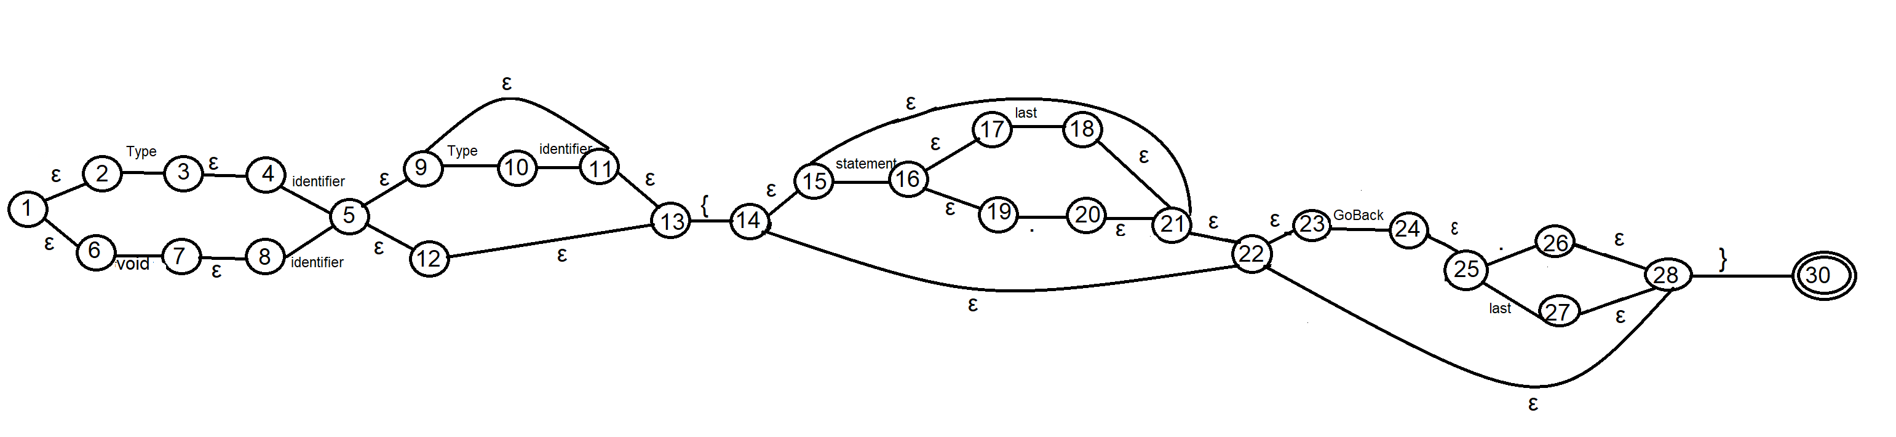

**(NFA) of Loop**

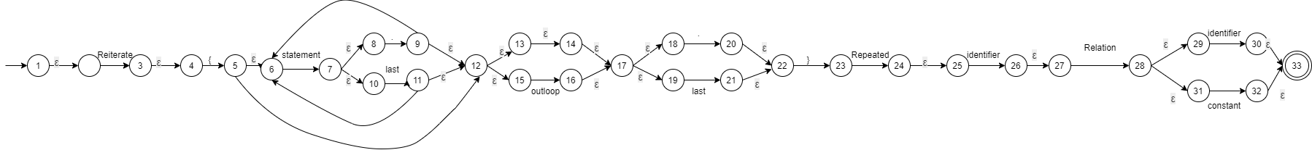

**(NFA) of Struct**

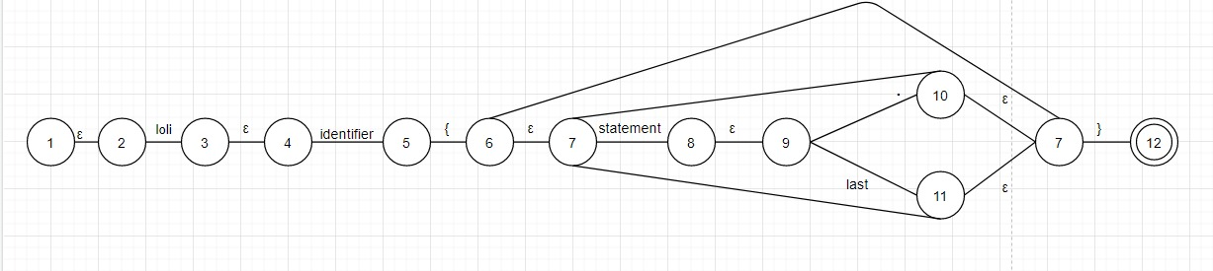

**(NFA) of Include**

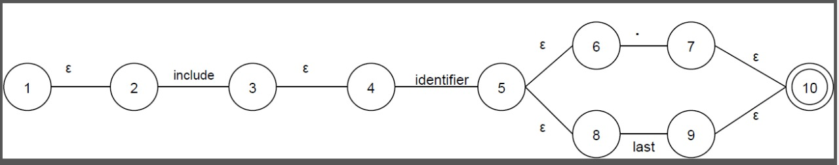

**Deterministic Finite Automata (DFA)**

**(DFA) of define var**

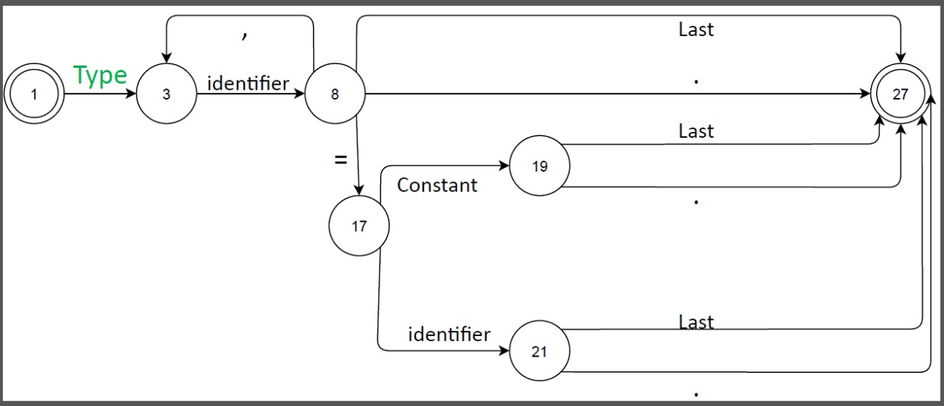

**(DFA) of Condition**

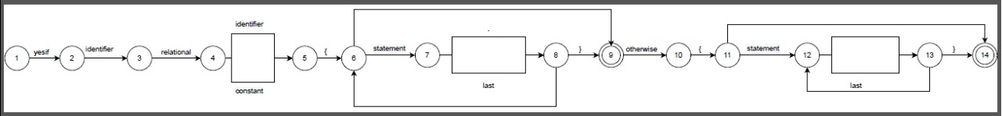

**(DFA) of Function**

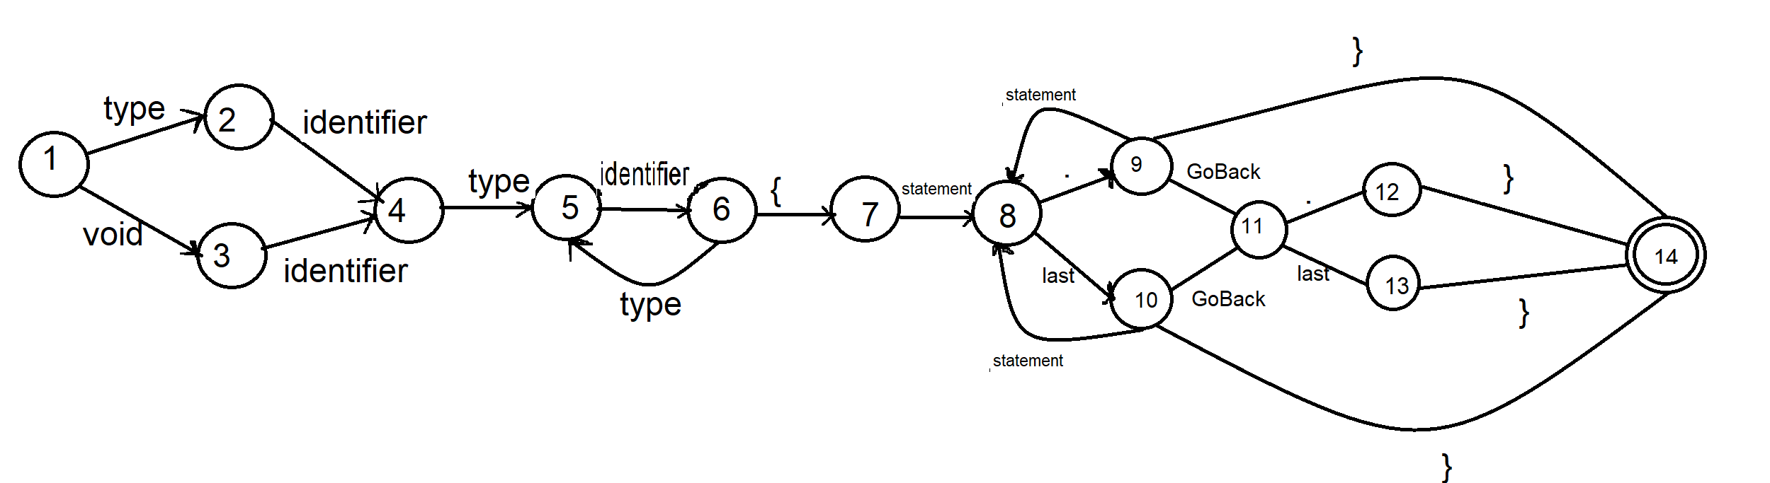

**(DFA) of Loop**



**(DFA) of Struct**

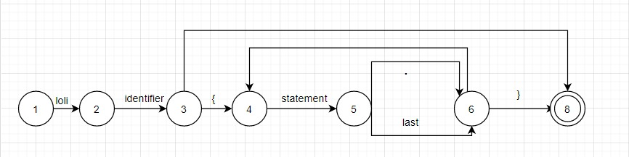

**(DFA) of Include**

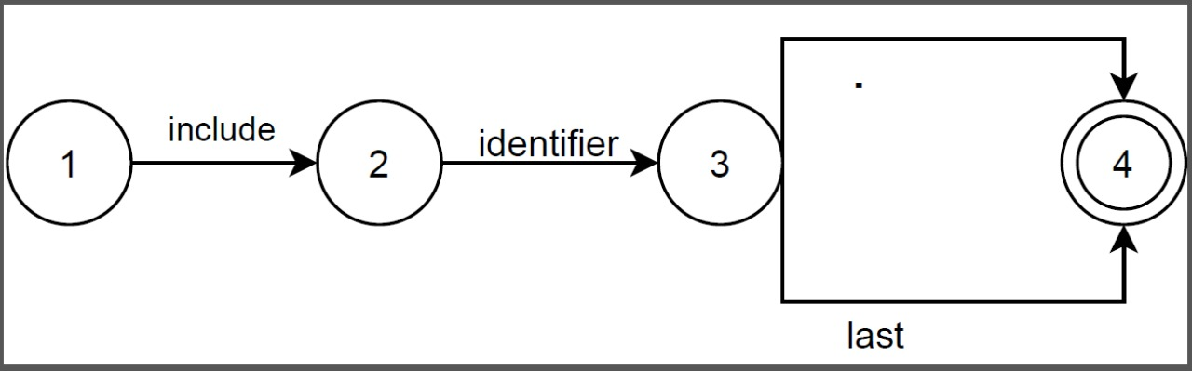

**Transition Table**

**Transition Table of Define Variable**

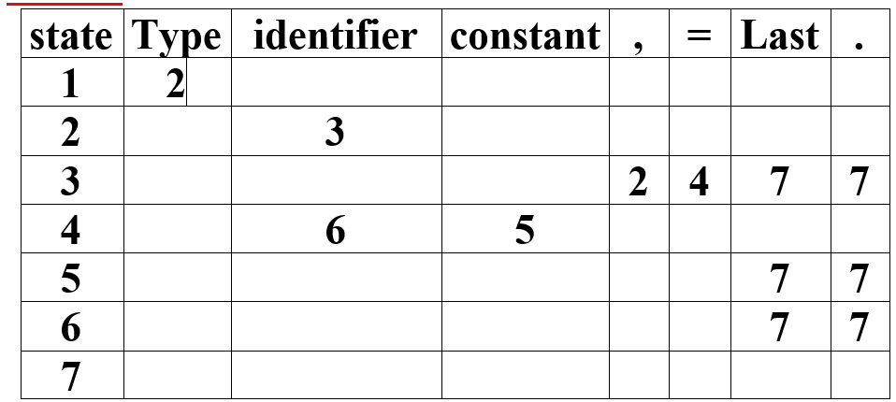

**Transition Table of Condition**

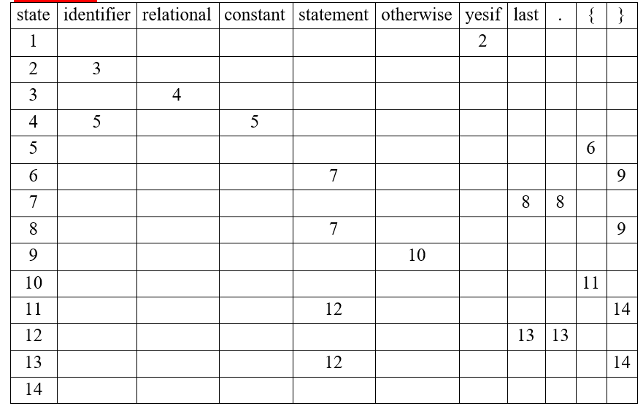

**Transition Table of Function**

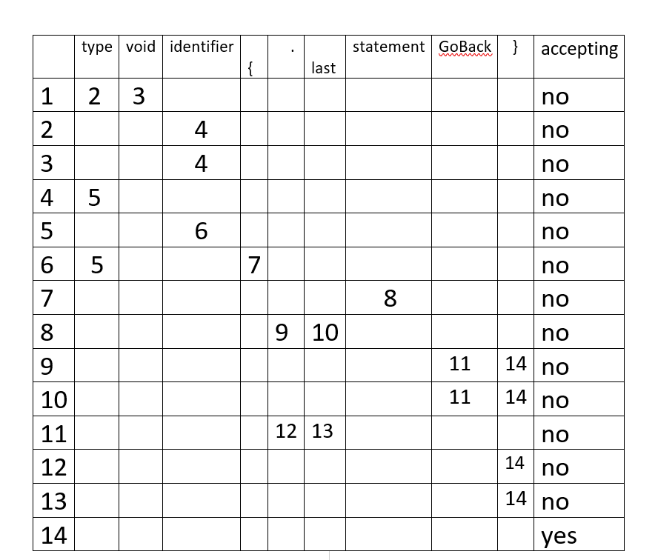

**Transition Table of Loop**

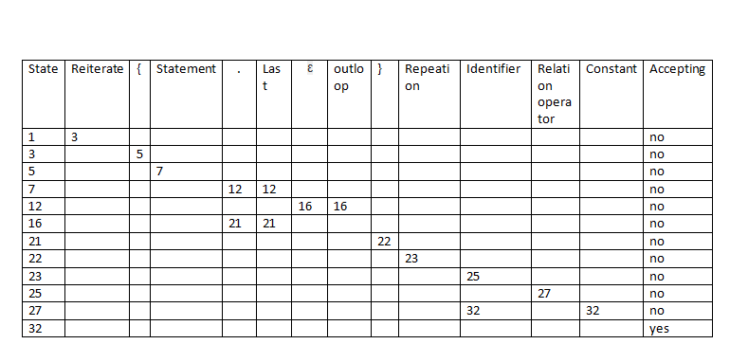

**Transition Table of Struct**

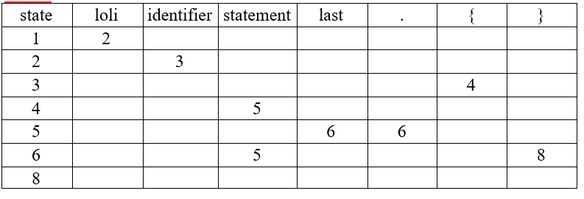

**Transition Table of Include**

